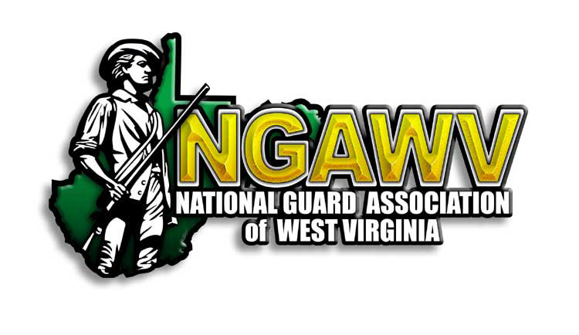

Dear Friend of the NGAWV,
On behalf of the National Guard Association of West Virginia, I would like to cordially invite you to attend our State Conference.
The 2022 NGAWV State Conference will be held on April 29-30, 2022 location TBD. Gold members will be invited to the Industry Partner Reception on the evening of the 29th. Our goal during the Industry Partner Reception is to place our industry partners with the leaders and decision makers in the WVNG you'd most like to exchange ideas with. This will strengthen our organization by allowing us to grow our understanding of capabilities that enhance our warfighter status. We encourage any recommendations on those positions. Gold and Silver members are invited to set up exhibits on April 30th to have general access to our WVNG members. We very much look forward to seeing you there.
The NGAWV is chartered in accordance with Section 501C(19) of the IRS code. Tax identification number 55-0488374.
Please visit NGAWV.org to register.

Feel free to contact me anytime with questions or if you'd prefer to register over the phone.

Thank you in advance for your support!

Very Respectfully,
Tom Mills
NGAWV – Executive Director
Email: ngawv1@gmail.com
Phone: 304-881-6198

APPLICATION FOR CORPORATE ASSOCIATE MEMBERSHIP 2022

(Sponsors paying by credit card please visit NGAWV.org and click Sponsors link)

The annual membership fee levels are:

Memberships | Annual Fee |  |  | Selection
Gold | $1,000.00 |  |  | [ ]
Silver | $500.00 |  |  | [ ]

Date:
Company:
Point of Contact:
Address:
City, State, Zip:
Contact Phone:
Email:
Check No: |  | Please make check payable to  NGAWV

**Credit Cards Accepted: Visa, MasterCard, American Express or Discover
Pay online at NGAWV.org

The NGAWV is chartered in accordance with Section 501c(19) of the IRS code.

Please submit completed application to address above or contact:
Tom Mills (Executive Director) at ngawv1@gmail.com

Corporate Associate Member Benefits

BENEFITS | Gold  1,000.00/yr | Silver  500.00/yr
Free 10x10 booth for exhibiting at the NGAWV Annual State Conference.  The 2022 NGAWV State Conference exhibitor booths will be held on April 30th location TBD. | Yes | Yes
Two invitations to NGAWV Annual State Conference Industry TAG Reception.  The 2020 NGAWV State Conference industry partner reception will be held on April 29th location TBD. | Yes | No
Company logo and contact information displayed on NGAWV website and at State Conference | Yes | Yes
Licensed to use the NGAWV logo on company publications | Yes | Yes

Thank you for your support!!

